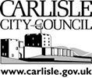
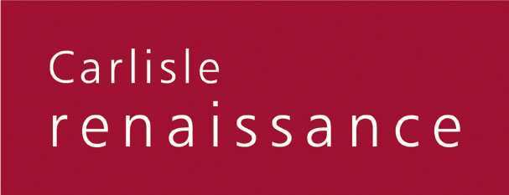

CITY CENTRE DEVELOPMENT FRAMEWORK
&
CITYWIDE MOVEMENT STRATEGY

DRAFT POLICY STATEMENT

Date of Issue: 26 March 2007
1. INTRODUCTION

1.1 Background

1.1.1 The Carlisle Renaissance Prospectus was launched in August 2005 and the vision and strategic objectives were formally endorsed by the City Council’s Executive in January 2006. This included the following strategic objectives: -

- Strengthening the City Centre, orientating it to the south and west, introducing new high quality mixed-use development with improved public realm and creating a vibrant waterfront environment

- Improving movement into and around the City for all modes of transport and promoting sustainable development that reduces dependence upon car travel

1.1.2 In November 2005 English Partnerships appointed a team of consultants on behalf of the City Council and other stakeholders to prepare a City Centre Development Framework & Citywide Movement Strategy. This report was published in January 2007 and provides the evidence base on which this Policy Statement is based.

1.2 Purpose

1.2.1 The purpose of this document is to set out the City Council’s policies to: -

- Stimulate investment in the City Centre by the private sector

- Establish a physical environment in and around the City Centre that supports economic growth

- Improve accessibility to jobs, services and facilities in the City Centre and throughout Carlisle

- Guide investment by the public sector in the City’s physical environment and infrastructure

1.3 Land Use & Transport Policy Context

1.3.1 The land use and transport policy context for this Policy Statement is contained in the following documents: -

- Draft North West Regional Spatial Strategy (2003-2021)
- Cumbria & Lake District Joint Structure Plan (2001-2016)
- Cumbria Local Transport Plan (2006-11)
- Carlisle Revised Redeposit Draft Local Plan (2006)

1.3.2 This Policy Statement is not a statutory document and therefore does not supercede any of these documents. However, it is the intention of the City Council to take full account of this Policy Statement in considering issues, making decisions and allocating resources as they relate directly or indirectly to the physical environment and infrastructure in Carlisle.

1.4 Consultation

1.4.1 In preparing this Policy Statement the City Council has undertaken extensive consultation with the resident and business community of Carlisle, relevant stakeholders and statutory organisations. Two public consultation exercises were undertaken, in January and September 2006 respectively, generating over 2,000 responses from individuals and organisations..

1.5 Format

1.5.1 This document is structured as follows: -

- Section 2 sets out the City Council’s spatial strategy for the City Centre and its immediate environs to the south and west, including the public realm and movement infrastructure

- Section 3 sets out the City Council’s proposals to strengthen and enhance the appearance, vitality and functionality of Core Character Areas and the contribution they make to the spatial strategy

- Section 4 sets out the City Council’s proposals to improve the quality, legibility and distinctiveness of the public realm in the City Centre and its immediate environs and along major corridors

- Section 5 sets out the City Council’s proposals to establish Carlisle as an exemplar City which offers a real choice of high quality transport modes for all

- Section 6 sets out the resource implications of this Policy Statement and arrangements for monitoring its implementation.

- A Glossary of Terms is included at the end of this document

2. SPATIAL STRATEGY

2.1 Vision

2.1.1 This City Council’s vision is to create a City Centre that is: -

- Competitive; where there is a balanced mix of uses that promotes Carlisle’s role as a sub-regional capital for retail, tourism, leisure, cultural, administrative and other services

- Distinctive; where the natural and built environment, including the topography, river corridors, green spaces, heritage and cultural assets, is enhanced and promoted

- Vibrant; where there is a wide choice of leisure and cultural events and activities for residents and visitors and a diverse evening and night time economy

- Legible; where there is a strong sense of place, the functions of different areas are easily interpreted and the connections between areas is coherent and inviting

- Accessible; where there is a balanced pattern of access, to, from and through the different areas, with an emphasis on public transport, pedestrian and cycling modes and the provision of high quality parking at gateway locations

- Sustainable; where new development demonstrates the highest standards of environmental performance and where public transport, pedestrian and cycling movement is promoted

- Safe & Well Managed; where the design of the public realm and the built environment promotes public safety and a sense of ownership and responsibility for residents and visitors

2.2 Core Character Areas

2.2.1 To support this vision the City Council will promote the concept of core character areas (CCAs) within and adjacent to the City Centre. It will encourage proposals to strengthen and enhance the appearance, vitality and functionality of these areas and the contribution they make to the spatial strategy.

2.2.2 The following eight CCAs have been identified: -

- Retail Core
- Historic Core
- Caldew Riverside
- Citadel
- Eastern Approaches
- Rickergate
- Botchergate South
- Western Gateway

2.2.3 The location of each of the CCAs is set out in the diagram below. There is overlap between CCAs in terms of the mix of uses and functionality. It therefore is not the intention to define specific boundaries for CCAs and areas shown should be regarded as illustrative only.

2.3 Public Realm

2.3.1 To support this vision the City Council will promote and support measures to:

- Upgrade the public realm on major road, rail, river, cycle and pedestrian corridors into the City Centre

- Establish a legible and coherent public realm in the City Centre that links together the CCAs

- Establish a public realm that is distinctive to Carlisle and fosters a sense of place

- Improve the maintenance and management of the public realm, to inspire civic pride

2.4 Movement

2.4.1 To support this vision the City Council will promote and support measures to: -

- Reduce through-traffic crossing the City Centre

- Improve the quality and scope of public transport throughout Carlisle

- Increase pedestrian and cycle use throughout Carlisle
- To provide high quality, safe gateway parking at strategic locations in and around the City Centre

- Become an exemplar City which offers a real choice of high quality transport modes for all

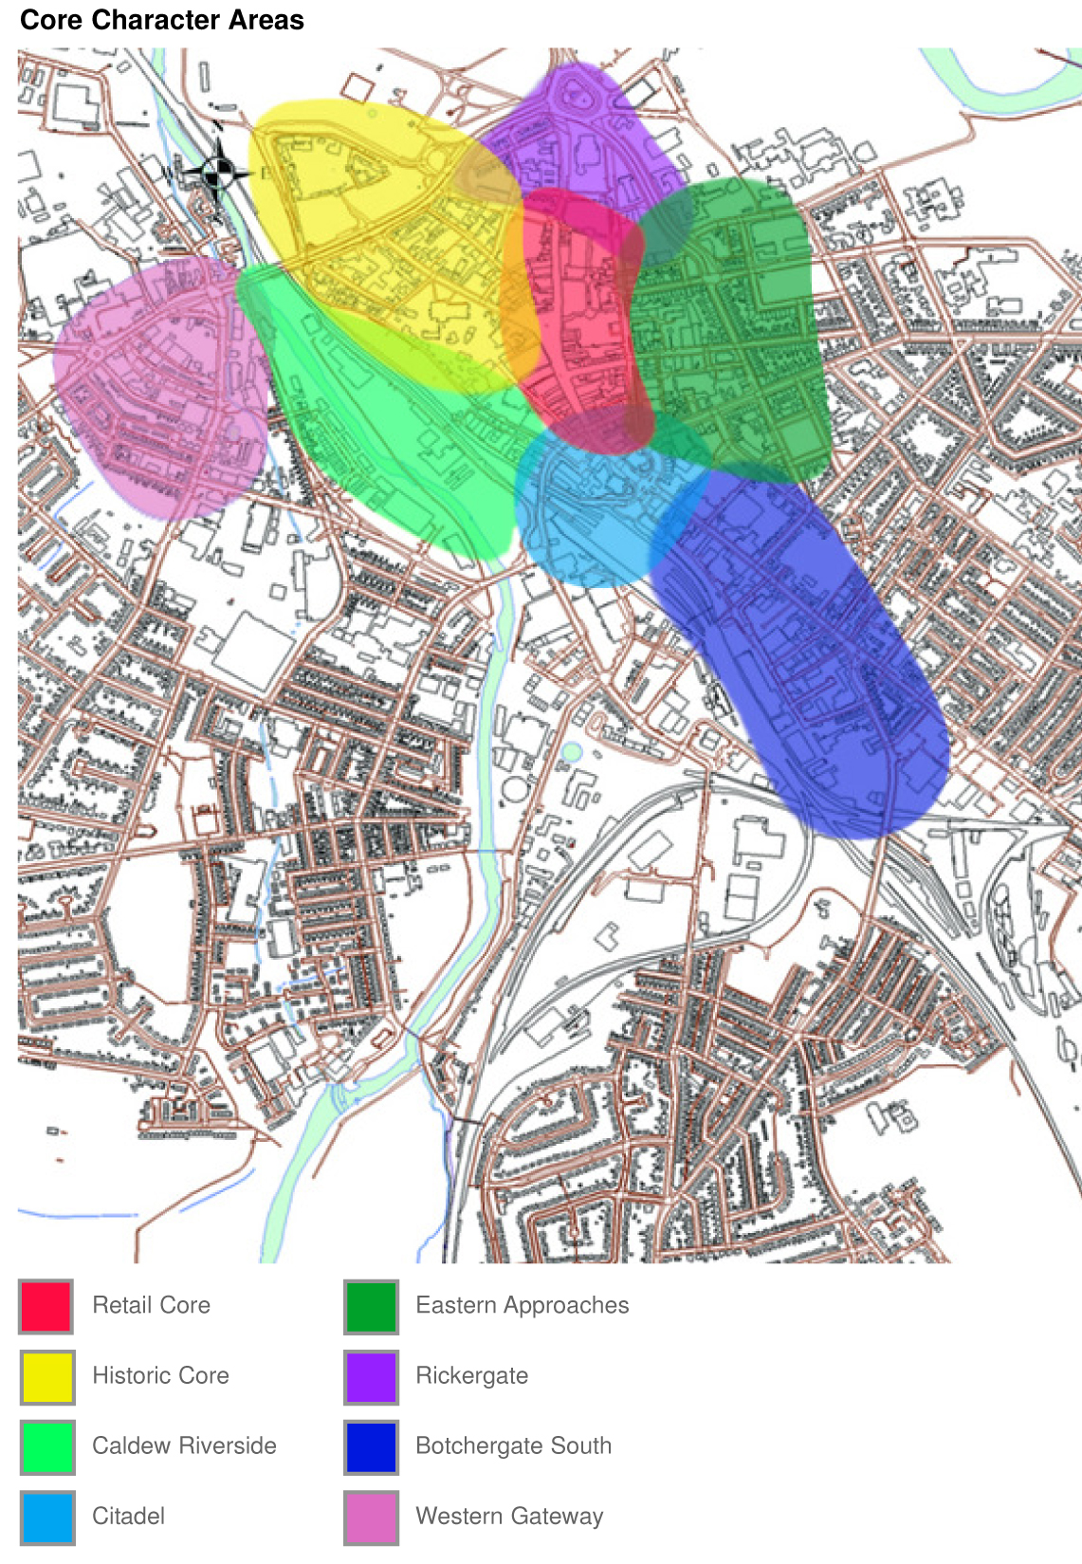
3. CORE CHARACTER AREAS

3.1 Retail Core

3.1.1 The City Council will promote the expansion of the Retail Core and the primary retail area into Rickergate. It will encourage the introduction of a broader mix of uses in the Retail Core to support the evening and night time economy and improvements to the quality of the public realm in the pedestrianised area. It will promote Green Market area as one of three major new or improved public squares in the City Centre.

3.1.2 The City Council will prepare a Public Realm Framework & Urban Design Guide covering all CCAs that will be used to define public realm schemes and design standards and direct public and private sector investment in the public realm. It will be adopted as a Supplementary Planning Document to the Carlisle Local Plan.

3.2 Historic Core

3.2.1 The City Council will promote the development of historic and cultural assets in the Historic Core such as the Castle, Cathedral and Tullie House. It also considers this area to be a potential location for a theatre / performing arts facility and associated uses.

3.2.2 The City Council will encourage niche/specialist retail in this area and the introduction of active uses along West Walls. It will support improvements to the quality of the public realm and connections between historic and cultural assets. The City Council will also support measures such as the reduction of on-street car parking and traffic calming to improve the pedestrian environment.

3.2.3 The City Council will prepare a Historic Core Strategy to improve the interpretation of the heritage environment and promote cultural leisure uses. It will undertake a Conservation Area Appraisal to protect and enhance the heritage environment and a study into options to reduce the severance impact of Castle Way on the Historic Core. This area will be covered by the Public Realm Framework & Urban Design Guide

3.3 Caldew Riverside

3.3.1 The City Council will promote office-led mixed-use development on the Viaduct Estate Road with active frontages along the River Caldew and considers this area to be a potential location for the University of Cumbria headquarters and associated uses.
3.3.2 The City Council will support improvements to the quality of the public realm along the railway corridor, including the Town Dyke Orchard car parking and the setting for West Walls. It will support measures to improve pedestrian and cycle access into and through this area, along the river corridor north to south and across the river to connect the City Centre to the west of the City.

3.3.3 The City Council will prepare a Development Brief for the Viaduct Estate Road that will be adopted as a Supplementary Planning Document to the Carlisle Local Plan. It will also prepare a Concept Statement for the Upper Viaduct car park. This area will be covered by the Public Realm Framework & Urban Design Guide

3.4 Citadel

3.4.1 The City Council will promote the development of Court Square as one of three major new or improved public squares in the City Centre and encourage residential-led mixed use development in the Bush Brow area.

3.4.2 The City Council will support improvements to the quality of the public realm, measures to improve pedestrian crossing facilities throughout this area and to establish high quality, secure gateway parking in the railway station area.

3.4.3 The City Council will prepare Concept Statements for sites in the Bush Brow area. This area will be covered by the Public Realm Framework & Urban Design Guide

3.5 Eastern Approaches

3.5.1 The City Council will encourage retail led mixed-use development in this area. It considers this area to be a potential location for the University of Cumbria headquarters and a theatre / performing arts facility and associated uses. The City Council also considers the site at the west of the junction of Warwick Road and Spencer Street to be suitable for use as a Magistrates Court / Criminal Justice Centre (incl. a police station)

3.5.2 The City Council will support improvements to the quality of the public realm, measures to reduce the impact of private vehicles on Lowther Street to reconnect retail uses in this area to the Retail Core and the redevelopment of the bus station.

3.5.3 The City Council will prepare a Concept Statement for the use of the site at the west of the junction of Warwick Road and Spencer Street as a Magistrates Court / Criminal Justice Centre (incl. a police station). This area will be covered by the Public Realm Framework & Urban Design Guide

3.6 Rickergate

3.6.1 The City Council will promote mixed-use development in Rickergate, accommodating expansion of the primary retail area, office, residential, hotel, leisure, cultural and associated uses. It will also seek to establish high quality, secure gateway parking in the area. The City Council considers this area to be a potential location for a theatre / performing arts facility and associated uses.

3.6.2 The City Council will promote the development of the area adjacent to the Market Hall and lower Scotch Street as one of three major new or improved public squares in the City Centre. It will support improvements to the quality of the public realm and measures to reduce the impact of private vehicles on West Tower Street and Drovers Lane.

3.6.3 The City Council will support the retention of existing properties in Corporation Road and Peter Street for residential and commercial uses and it intends to retain a significant presence in Rickergate and will promote the area as a location for other public sector occupiers.

3.6.4 The City Council will prepare a Development Brief for Rickergate that will be adopted as a Supplementary Planning Document to the Carlisle Local Plan. This area will be covered by the Public Realm Framework & Urban Design Guide

3.7 Botchergate South

3.7.1 The City Council will promote a shift to a predominance of residential-led mixed-use development in Botchergate South and considers this area to be a potential location for the University of Cumbria headquarters and associated uses.

3.7.2 The City Council will promote improvements to the quality of the public realm in this area, including along the railway and A6 corridor. It will support measures to improve the routing of traffic from the south to the west of the City Centre through this area and to establish high quality, secure gateway parking.

3.7.3 The City Council will prepare an Area Action Plan for Botchergate South that will be adopted as a local development document of the Carlisle Local Plan. This area will be covered by the Public Realm Framework & Urban Design Guide

3.8 Western Gateway

3.8.1 The City Council will promote residential-led mixed-use development in the Western Gateway and an increase in the density of development where appropriate. The site of the former market on John Street is considered potentially suitable for a high quality gateway development.

3.8.2 The City Council will promote improvements to the quality of the public realm in the area including the Shaddongate and Bridge Street corridor and will encourage the highest quality development adjacent to significant junctions along these corridors.

3.8.3 The City Council will prepare a Development Brief for the Western Gateway that will be adopted as a Supplementary Planning document of the Local Plan. It will also prepare a Concept Statement for the John Street site. This area will be covered by the Public Realm Framework & Urban Design Guide

4. PUBLIC REALM

4.1 The City Council will promote improvements to the quality of the public realm along the following corridors: -

- The mainline railway in the immediate northern and southern approaches to Citadel Station

- The River Caldew from Denton Holme to the Sheepmount and the River Eden between the River Caldew and the River Petteril

- The A69 at Botcherby Bridge, the A6 between St Nicholas Retail Park and Botchergate and Church Street / Shaddongate.

- Castle Way from Hardwicke Circus to Bridge Street and Georgian Way from Hardwicke Circus to Spencer Street.

4.2 The City Council will seek to establish a legible and coherent public realm in the City Centre that links together the CCAs by: -

- Promoting three major new or improved public squares in the City Centre at Court Square in front of the Citadel station, the Green Market area adjacent to the Old Town Hall and the area of Rickergate adjacent to the Market Hall and lower Scotch Street

- Promoting high quality public realm at the interface between the Retail Core and the Historic Quarter, the Retail Core and Citadel, Citadel and Caldew Riverside, and between Caldew Riverside and the Historic Quarter.

4.3 The City Council will seek to establish a public realm that is distinctive to Carlisle and fosters a sense of place by promoting the use of locally distinctive materials and styles appropriate to specific locations and through the use of public squares for a varied mix of events and activities.

4.4 The City Council will seek to improve the maintenance and management of the public realm and inspire civic pride by: -

- Promoting a lifecycle approach to the commissioning, specification, installation and maintenance of public realm improvement

- Investigating mechanisms such as a Business Improvement District or a City Centre Management Company to generate additional investment by the private sector
4.5 The City Council will prepare a Public Realm Framework & Urban Design Guide covering all CCAs. It will be used to define public realm schemes and design standards and direct public and private sector investment in the public realm It will be adopted as a Supplementary Planning Document to the Carlisle Local Plan.

5. MOVEMENT

5.1 The City Council will support measures to: -

- Reduce the incidence of through traffic using Lowther Street whilst retaining its function as an important public transport corridor and access route for commercial uses

- Reduce the severance impact of Castle Way, taking advantage of forecast reductions in through traffic arising from the Carlisle Northern Development Route

- Improve inner orbital traffic flows from the south of the City Centre through designated South Western and South Eastern relief routes.

- Establish high quality, secure and accessible gateway parking in the Rickergate, Botchergate South, Citadel and Caldew Riverside CCAs.

- Improve signing and routing for all modes of transport into and thoughout the City Centre.

- Improve bus routing throughout Carlisle, including cross-city transit routes, and interchanges between other transport modes (road, rail, pedestrian and cycle). This should include consideration of options for Park & Ride and Bus Station facilities

- Utilise river and other green corridors to improve pedestrian and cycle access into the City Centre from residential areas

- Improve the pedestrian environment in the Historic Core. This should include options for reducing on-street car parking and traffic calming

- Improve pedestrian and cycle access from the City Centre to the Hadrian’s Wall route

5.2 The City Council will work jointly with the County Council to: -

- Integrate measures to improve movement into and around Carlisle into the Carlisle Area Transport Plan, including resources to undertake options appraisals and other preparatory work as might be required

- Prepare a new Car Parking Strategy for Carlisle

- Prepare Supplementary Planning Guidance on Planning Obligations to financial contributions from developers to movement and public realm projects
6. RESOURCE IMPLICATIONS & MONITORING

6.1 Local Development Scheme (LDS)

6.1.1 This Policy Statement gives direction to the preparation of Local Development Documents that will be adopted by the City Council and form part of the Carlisle Local Plan. These are: -

- Development Brief for Rickergate (SPD)

- Development Brief for the Caldew Riverside (SPD)

- Development Brief for the Western Gateway (SPD)

- Public Realm Framework & Urban Design Guide (SPD)

- Area Action Plan (AAP) for Botchergate South

- Planning Obligations (SPD)

6.1.2 The City Council will incorporate these into the LDS, which sets out the local development documents that form part of the Carlisle Local Plan and the programme for the preparation of these documents over a three-year timeframe.

6.2 This Policy Statement gives direction to the preparation of the following documents that will not form part of the LDS: -

- Carlisle Car Parking Strategy
- Castle Way Options Study
- Historic Core Strategy
- Historic Core Conservation Area Appraisal
- Upper Viaduct Car Park Concept Statement
- Warwick Road / Spencer Street Junction (West) Concept Statement
- Bush Brow area Concept Statements.
- John Street area Concept Statement

6.3 Funding & Staff Resources

6.3.1 The City Council has secured external funding from the Northwest Development Agency to progress many of the local development and other documents outlined above. It has committed resources in the period to 2008/09 for the provision of additional staff and technical support in planning and development management.
6.3.2 The City Council is currently assessing potential delivery models for the DF&MS and other aspects of Carlisle Renaissance, such as a City Development Company or an Urban Regeneration Company, and sources of both revenue and capital funding to support delivery.

6.3.3 The City Council will consider its own financial commitment to delivery through its Medium Term Financial Plan and will continue to encourage other stakeholders to make sufficient resources available as required to support this

6.4 Monitoring

6.4.1 The City Council will produce an annual monitoring report to assess progress made in respect of this work and the contribution it makes towards achieving the aims and objectives of this Policy Statement
GLOSSARY OF TERMS

Accessibility
The ease with which a building, place or facility can be reached by people and/or goods and services.

Area Action Plan (AAP)
A plan that assesses the future development opportunities of a specific area for a mix of uses not currently designated in the Local Plan. The process of preparing an AAP normally takes three years and includes extensive public consultation.

Business Improvement District (BID)
A scheme where commercial owners and occupiers in a specific area agree to pay an additional levy on their business rates to finance environmental improvements, security, local events and marketing and promotion

Built Environment
A phrase which refers to buildings and physical infrastructure in a particular area

Concept Statement
A document that provides design advice for a site where it is needed quickly and the proposed uses are permitted within the framework of the Local Plan

Carlisle Renaissance Prospects
A document that sets out the vision and strategic objectives for long term physical, economic and social regeneration

City Development Company (CDC)
A new concept promoted by Central Government, it is based on the establishment of a special purpose vehicle (such a limited company) to deliver economic interventions and act as a catalyst for the revival of local economies

Conservation Area Appraisal
A process that defines the character and historical context of an existing Conservation Area, the contribution and importance of buildings and other heritage assets in the area and set the framework for investment to protect and enhance the physical environment

Corridors
Linear road, railway, pedestrian, cycle and river approaches to an area such as the City Centre.

Carlisle Northern Development Route (CNDR)
The outer ring road between the M6 motorway (junction 44) and the A595 south west of Carlisle.

Criminal Justice Centre
A centre where the main aspects of the criminal justice service are administered, such as the Courts, the Crown Prosecution Service, the Police and Probationary Service

Development Brief
A document that provides guidance on how a specific site or area should be developed in accordance with the Local Plan, typically including indicative plans, layouts etc.

English Partnerships
The Governments National Regeneration Agency for England

Environmental Performance (Development)
Refers to factors such as the source of materials used in a development, levels of energy use in the completed development etc.

Exemplar City
A model of best practice that serves to promote the area as an example to others

Gateway Development
A high quality development at a transitional location, i.e. where there is major change in the pattern of uses

Gateway Parking
High quality, safe car parking located in areas adjacent to the City Centre easily accessible from radial routes

Heritage and Cultural Assets
Buildings and other facilities that are of historic or cultural interest within the City

Legibility
The degree to which an area can be easily understood by its users and the clarity of the image it presents
Life Cycle Approach
An approach that considers all aspects to the life of a development project, from commissioning, design, sourcing of materials and installation though to maintenance, management and long term replacement.

Local Plan
A land use planning document which aims to guide new development to sustainable locations within a local authority area

Local Development Documents (LDDs)
A range of statutory documents that form the Local Plan for specific issues and areas

Local Development Scheme (LDS)
A schedule of proposed Local Development Documents and the programme for preparing them

Medium Term Financial Plan (MTFP)
The MTFP is the City Council’s three-year financial plan

Mixed Use Development
A development that comprises a mix of complementary uses within a building, on a site or within a particular area

Public Realm
The parts of an area (whether publicly or privately owned) that are available (without charge) for people to use or see, including streets, squares and parks

Spatial Strategy
An approach to planning that involves linking physical, economic and social factors together for a particular area

Supplementary Planning Document (SPD)
A document adopted by the City Council that sets out additional details in relation to a Local Plan Policy on a specific issue of for a specific site or area. SPDs must be linked to a policy in the Local Plan.

Sustainable Development
Defined as development that meets the needs of the present without compromising the ability of future generations to meet their own needs

Transport Modes
These are the different methods of transport that people use to move around and typically include car, bus, rail, cycle and walking.

Urban Regeneration Company (URC)
An organisation established to fulfil a co-ordinating role in the delivery or regeneration in an area. Over 20 URCs been established in England since the late 1990’s (for more information visit www.urcs-online.co.uk)

