Governance Directorate

Assistant Director (Governance): M D Lambert LLB (Hons), MBA

Civic Centre Carlisle CA3 8QG Telephone (01228) 817000 Fax (01228) 817072

Document Exchange Quote DX 63037 Carlisle Type talk 18001 01228 817000

TO: THE CHAIRMAN AND MEMBERS  OF THE AUDIT COMMITTEE |  | Please ask for: |  |  |  | Mrs Durham
TO: THE CHAIRMAN AND MEMBERS  OF THE AUDIT COMMITTEE |  | Direct Line: |  |  | 01228 817036
TO: THE CHAIRMAN AND MEMBERS  OF THE AUDIT COMMITTEE |  | E-mail: | MoragD@carlisle.gov.uk
TO: THE CHAIRMAN AND MEMBERS  OF THE AUDIT COMMITTEE |  | Your ref:
TO: THE CHAIRMAN AND MEMBERS  OF THE AUDIT COMMITTEE |  | Our ref: |  | MD
15 October 2010

Dear Member

CHANGE OF DATE - AUDIT COMMITTEE

As you will be aware, the next meeting of the Audit Committee was scheduled to take place at 10.00 am on Monday 1 November 2010.

Please note however that, on the instruction of the Chairman, that meeting has been postponed and will now take place on Tuesday 30 November 2010 at 10.00 am in the Flensburg Room. This is to enable the Audit Commission / Officers to provide updates on the issues raised by the Committee at their last meeting.

I should be grateful if you would amend your diary to reflect the above.

Yours faithfully
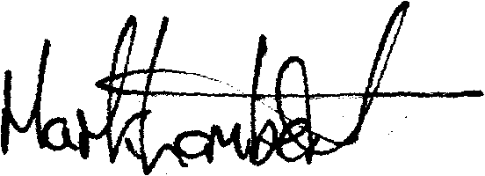

Assistant Director (Governance)

