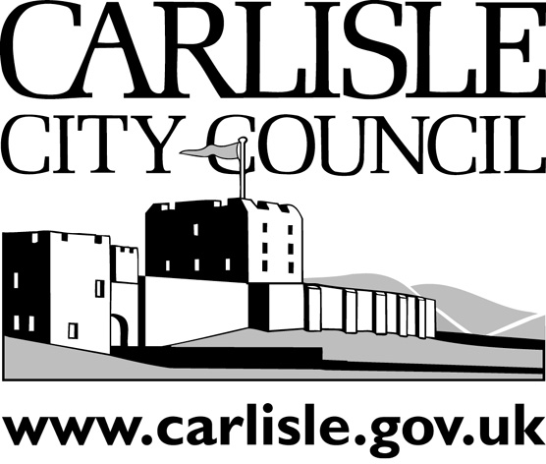
REPORT TO EXECUTIVE
PORTFOLIO AREA: CORPORATE RESOURCES
Date of Meeting: |  |  | 13th June 2005
Public
Key Decision: | No |  |  |  | Recorded in Forward Plan: | No
Inside Policy Framework

Title: | JANUARY FLOOD - EMERGENCY PLANNING REVIEW
Report of: | Overview and Scrutiny Manager
Report reference: | OS.02/05

Summary:
The report summarises the debrief process and its outcomes in relation to the City Council’s Emergency Planning responsibilities.

Recommendations:
- Executive are asked to note the review which has taken place and endorse the Action Plan
- b. Note that Corporate Resources Overview and Scrutiny Committee will also be receiving this report on 16th June 2005 and monitoring implementation of the Action Plan

Contact Officer: | John Mallinson | Ext: | 7010
- BACKGROUND INFORMATION
Members are well aware of the January storm and flood, which caused such extensive damage and disruption. Members have also received periodic reports on the response to the disaster and the ongoing recovery work.

It is obviously good practise to learn from experience and in emergency incidents a debrief is always held to capture and act upon that learning. Government Office North West (GONW) is leading on the multi-agency debrief and will be producing an overall report. The timescale for this report has been extended because of the election period but it will be reported to Members as soon as it is available.

It is clear from the various debrief sessions held that the City Council’s response is highly regarded by partner agencies. It is also abundantly clear that City Council staff responded magnificently in very difficult circumstances. They showed great dedication and creativity whilst working long hours, often working outside their normal roles, and the commitment and corporate working across units and teams paid great dividends.

This report deals with learning in relation to the City Council’s own response to enable it to be better prepared for any future event, wider issues will be dealt with in the GONW report.

2. CITY COUNCIL’S EMERGENCY RESPONSIBILITIES
Carlisle City Council’s responsibilities, as a district council, are defined within the County General Emergency Plan, which is a key element of the well-established emergency planning arrangements in Cumbria.

The council provides support for the emergency services, whilst maintaining core services, it is a lead player in the multi-agency arrangements to effectively manage an incident including the Gold and Silver Command Structure. Its services and facilities are deployed as appropriate to provide an effective response and to mitigate the effects of the emergency.

In normal circumstances the authority has specific responsibility for providing and administrating an Emergency Control Centre (usually at the Civic Centre) but, as the Civic Centre was itself flooded, this was provided at The Castle.

The management of Reception Centres, Public Information facilities and Telephone Enquiry services also fall to the City Council and were extensively used in this incident.

Once the acute phase of an incident is over the City Council leads on recovery and this huge task is still ongoing. Aspects of recovery include: - clean-up and waste collection; tackling damage to trees, civic properties and infrastructure; addressing a wide range of welfare needs; advice and support services; temporary housing of displaced residents and ensuring satisfactory refurbishment of properties.

3. REVIEW PROCESS
Executive Management, the Overview and Scrutiny Manager (the Council’s Lead Officer on Emergency Planning) and the Head of Commercial and Technical Services did, as the incident unfolded, record areas for potential improvement and have discussed the Council’s response in depth. Other officers who were closely involved have similarly contributed to this learning process. Corporate Management Team held an extensive debrief session and these all influenced inputs to GONW’s various debrief sessions and the Action Plan, which is appended to this report.
The Action Plan is detailed and largely self-explanatory, most actions can be delivered within existing resources but if any require additional funding then this will be addressed through the normal Business Planning Process. It is proposed that Corporate Resources Overview and Scrutiny Committee will monitor the Action Plan’s implementation and a further report on progress will be submitted to that committee in the autumn.

- RECOMMENDATIONS
- Executive are asked to note the review which has taken place and endorse the Action Plan
- Note that Corporate Resources Overview and Scrutiny Committee will also be receiving this report on 16th June 2005 and monitoring implementation of the Action Plan

- REASONS FOR RECOMMENDATIONS
To inform Members of the review and its outcomes

- IMPLICATIONS
- Staffing/Resources – Any staffing/resource implications arising will be dealt with through the normal Business Planning Process

- Financial – Any financial implications arising will be dealt with through the normal Business Planning Process

- Legal – Implementation of the Action Plan will assist in discharging the Council’s Civil Contingencies Act duties

- Corporate – Corporate Management Team have endorsed the Action Plan

- Risk Management – There are no significant risks involved in implementing the Action Plan

- Equality Issues – None envisaged

- Environmental – None envisaged

- Crime and Disorder – None envisaged

- Impact on Customers – The Council will be better placed to respond in any future emergency

