REPORT TO EXECUTIVE
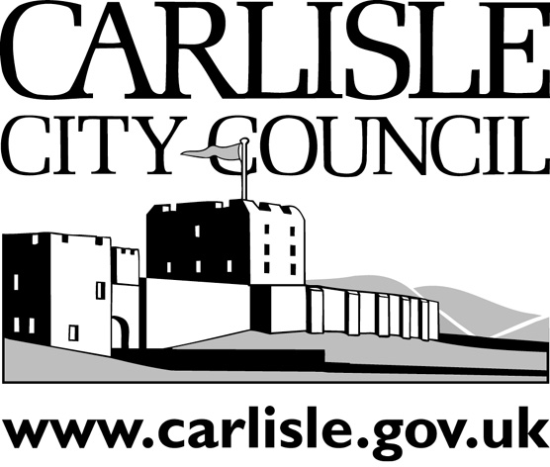
PORTFOLIO AREA: FINANCE & RESOURCES
Date of Meeting: |  |  | 20 June 2005
Public
Key Decision: | Yes |  |  |  | Recorded in Forward Plan: | Yes
Inside Policy Framework: Yes

Title: | DRAFT ASSET MANAGEMENT PLAN
Report of: | HEAD OF PROPERTY SERVICES
Report reference: | PS 08/05

Summary:

This report provides a draft of this year's Asset Management Plan for Members’ consideration.
It has been reviewed in the light of the Beacon assessment, January floods and the Council’s key priorities.

Recommendations: It is recommend that:

The Executive approve the Asset Management Plan in principle and it proceed to consultation – including consideration by the Corporate Resources Overview & Scrutiny Committee.

Contact Officer: | David Atkinson | Ext: | 7420

- BACKGROUND INFORMATION & OPTIONS
  - The Asset Management Plan has been a key document in the Council’s financial planning process since it was introduced through Government guidance in 2001.
  - The attached report provides this year’s plan in draft form.
  - The key features to note include that the Beacon assessment reviewed progress. Recommendations are outlined in the plan.
  - The Council is setting new priorities through its current corporate process and the plan incorporates them.
  - There are also important issues in respect to the strategic and operational approach in the aftermath of the flood.
  - Some authorities are proceeding towards a two stage approach in the development of their plans. Firstly, a fairly static outline demonstrating the formal processes. Secondly, a flexible addendum which can be reviewed regularly as a working plan.
  - If Members’ wish, this approach will be developed and reported back later in the municipal year.

- CONSULTATION
  - Consultation to date: Corporate colleagues
  - Consultation proposed: Medium Term Financial Special Planning Group; Corporate Resources Overview and Scrutiny Committee; appropriate business stakeholders.

- RECOMMENDATIONS It is recommend that:
  - The Executive approve the Asset Management Plan in principle and it proceed to consultation – including consideration by the Corporate Resources Overview & Scrutiny Committee.

- REASONS FOR RECOMMENDATIONS
  - To approve the draft Asset Management Plan in advance of consultation.

