    Town Hall Penrith Cumbria CA11 7QF  Telephone: (01768) 864671  Facsimile: (01768) 890470  Internet: www.eden.gov.uk  Email:cttee.admin@eden.gov.uk | Civic Centre Carlisle CA3 8QG Telephone (01228) 817000  Fax (01228) 817048  Document Exchange Quote DX 63037 Carlisle  Type talk 18001 01228 817000  Please ask for Mr Dixon  Direct Line 01228 817033  E-mail IanD@carlisle-city.gov.uk

Dear Councillor

Carlisle Eden Joint Committee 2 December 2005

I would like to advise you that the meeting of the Carlisle Eden Joint Committee scheduled to be held on 2 December 2005 has been cancelled due to lack of business.

Please note that the next meeting is due to be held on Friday 10 February 2006 in Penrith.

Yours faithfully

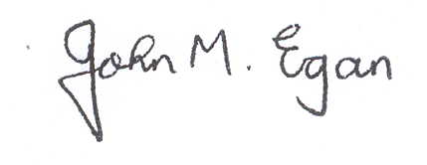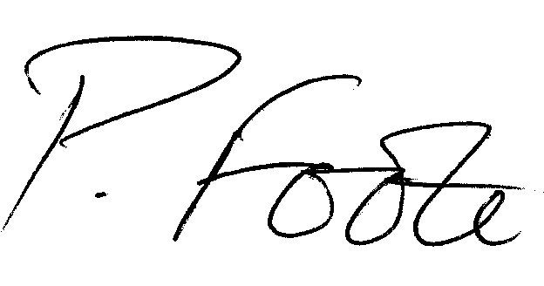

J M Egan  Head of Legal and Democratic Services | P G Foote  Director of Corporate and Legal Services

FOR ATTENTION

All Members of the Eden and Carlisle Joint Advisory Committee

Carlisle City Council  Councillor R Bloxham  Councillor E Firth  Councillor R Knapton  Councillor M Mitchelson | Eden District Council  Councillor B Metz  Councillor D I A Nattrass  Councillor C Nineham  Councillor J M Smith

