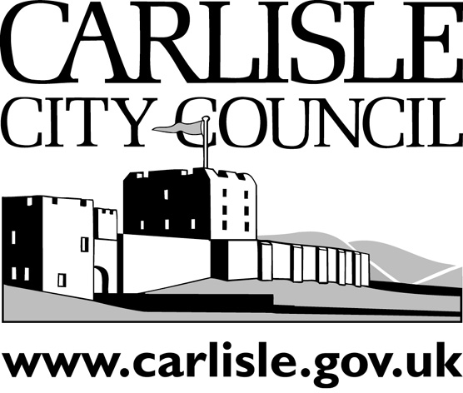
INFRASTRUCTURE OVERVIEW & SCRUTINY COMMITTEE

Committee Report
Public
Date of Meeting: | 10th April 2008
Title: | Urban Design Guide & Public Realm Framework Supplementary Planning Document – Consultation Draft
Report of: | Director of Development Services
Report reference: | DS.47/08

Summary:
The attached report, which was presented to the Executive on 7 April 2008, sets out the background to the preparation of a Supplementary Planning Document comprising an Urban Design Guide and Public Realm Framework, predominantly for Carlisle City centre. Part of the process of adoption of the document as a Supplementary Planning Document is formal consultation hence the form and contents of what will be subject to that consultation needs to be agreed by the City Council.

The draft Urban Design Guide and Public Realm Framework is appended to the Report and Overview & Scrutiny is requested to consider this draft and refer it back to Executive Committee for further consideration. It will then pass to Full Council for agreement.

Questions for / input required from Scrutiny

- Consider and comment upon the general contents of the draft Urban Design Guide & Public Realm Framework appended to the Report.
- Comment upon the sections of the document relating to Character Areas specific design guidance – pages 23-56
- Comment upon the sections of the document relating to Public Realm Component and Materials – pages 91-94 and details in pages 95-114
Recommendation

The Committee is requested to consider the draft Urban Design Guide & Public Realm Framework Supplementary Planning Document and refer its comments back to the Executive.

Contact Officer: | Chris Pearson & Chris Hardman | Ext: | 7015 / 7190

