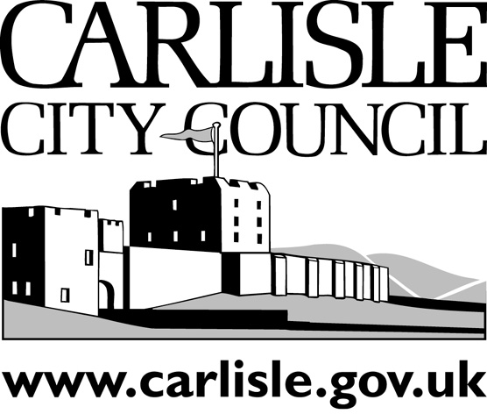
REPORT TO EXECUTIVE
PORTFOLIO AREA: CROSS-CUTTING
Date of Meeting: |  |  | 2nd September 2010
Public
Key Decision: | No |  |  |  | Recorded in Forward Plan: | No
Inside/Outside Policy Framework

Title: | PETITION - THE WAVERLY VIADUCT
Report of: | ASSISTANT DIRECTOR (ECONOMIC DEVELOPMENT)
Report reference: | ED.24/10

Summary:
A petition has been submitted to the City Council requesting that the City Council and/or Cumbria County Council enter into discussions with the landowner of the Waverly Viaduct with an intention to purchase the viaduct in order to create an environmentally friendly route across the River Eden. The discussions would have cross cutting implications for officers in planning, property and highways.

Recommendations:
That officers continue discussions with the owners of the viaduct and a report on the considerations referred to in this petition is presented to Executive in due course.

Contact Officer: | Chris Hardman | Ext: | 7502
- BACKGROUND INFORMATION AND OPTIONS

A petition has been received from Sustainable Carlisle and a request that this be brought to the attention of the Council’s Executive. A sample of the petition is attached to this report however the full petition comprises 2418 signatures.

The petition requests that Carlisle City Council and/or Cumbria County Council enter into discussions with the owner of the Waverly Viaduct (namely British Railways Board) to agree the purchase of this listed structure, formerly a railway viaduct on the disused Waverly Route to Edinburgh. That the viaduct is restored and maintained in a state which befits a Grade 2 listed structure to secure its future use as a means of access. That the Council’s apply for financial assistance towards the restoration or as part of a “Renaissance” scheme and that discussions are held with local landowners to establish suitable approach routes to the viaduct for walking and cycling.

Members may recall that in May a similar petition was reported to City Council. At the time that petition comprised 554 signatures although Members were informed that there were additional petition sheets with the organiser as well as an on-line petition still underway.

City Council resolved:
(1) That the petition and report relating to the Waverly Viaduct be received.
(2) That discussions are undertaken with Cumbria County Council as to the future options and potential role for the Viaduct in the transport network around Carlisle. The Portfolio Holder and a representative of the organisers of the petition be involved and kept informed of progress.

The current petition includes a covering letter which highlights the potential for the Connect2 cycleway and links to the concerns about traffic generation from the proposed development at Crindledyke. The letter urges the City Council to start discussions with the British Rail Board as soon as possible.

Since the Council resolution officers have been in discussion with the owners of the Waverly Bridge involving the Council’s property and planning teams and officers dealing with the Sustrans route are also aware of the public interest in the viaduct in relation to that scheme and connection to the Sustrans route. The condition of the viaduct is being investigated by the current owners and temporary fences have been installed which prevent access due to concerns about safety as the parapet has been removed in places. In order to address the matters referred to in the petition this work would have to continue.

- CONSULTATION

  - Consultation to Date.
The petition contains 2148 signatures
  - Consultation proposed.
n/a

- RECOMMENDATIONS

That officers continue discussions with the owners of the viaduct and a report on the considerations referred to in this petition is presented to Executive in due course.

- REASONS FOR RECOMMENDATIONS

In recognition that a longer term solution needs to be found for the Waverly Viaduct

- IMPLICATIONS
- Staffing/Resources – Some staff resource will have to allocated to continue these discussions and will involve staff in different directorates.

- Financial – Future options arising from any discussions will have to be appraised for their financial implications

- Legal – There is currently an obligation on the owner to ensure that the Listed Building is maintained but no legal obligation to allow public access.

- Corporate – Future consideration will take into account the Council’s priorities.

- Risk Management – Risks will have to be identified arising from future discussions

- Environmental – The petition refers to the provision of a sustainable route and links to the Sustrans route which may generate sustainable travel

- Crime and Disorder – There have been concerns about vandalism to the fences at either end of the Viaduct resulting in the recent planning application

- Impact on Customers – The petition has arisen from the Council’s customers and this would take forward concerns they have raised

- Equality and Diversity –

Impact assessments

Does the change have an impact on the following?

Equality Impact Screening | Impact Yes/No? | Is the impact positive or negative?

Does the policy/service impact on the following?
Age | No
Disability | No
Race | No
Gender/ Transgender | No
Sexual Orientation | No
Religion or belief | No
Human Rights | No
Social exclusion | No
Health inequalities | No
Rurality | No

If you consider there is either no impact or no negative impact, please give reasons:

This report considers a petition to undertake discussions regarding the Waverly viaduct. Detailed proposals will be able to be considered at a later date when further discussions have taken place. Further consideration at that time will be able to consider specific impacts.
.....................................................................................................................................................................................................................................................................................................................................................................................................................................................................

If an equality Impact is necessary, please contact the P&P team.

