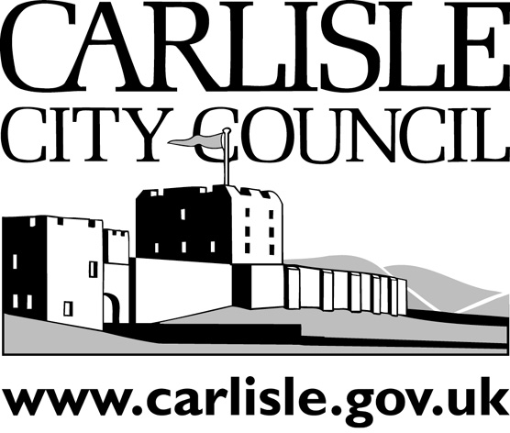
REPORT TO EXECUTIVE
PORTFOLIO AREA: |  | ENVIRONMENT AND INFRASTRUCTURE
Date of Meeting: |  | 12 June 2006
Public
Key Decision: | Yes |  |  | Recorded in Forward Plan: | Yes
Inside Policy Framework

Title: | LOCAL AIR QUALITY UPDATING & SCREENING ASSESSMENT
Report of: | Head of Community Services
Report reference: | CS 21/06

Summary:

The appended report provides required information on local air quality for Carlisle and district and concludes that it will be necessary to declare an additional Air Quality Management Area.

Recommendations:

It is RECOMMENDED that:-
- the findings of the updated assessment be submitted to the Secretary of State in accordance with the Environment Act 1995
- An Air Quality Management Area be declared for part of Currock Street, Carlisle

Contact Officer: | David Ingham  Environmental Quality Manager | Ext: | 7328
- BACKGROUND INFORMATION AND OPTIONS

1.1 Introduction

This is an Updating and Screening Assessment Report on Local Air Quality for the Carlisle City Council area and forms the first stage of the third round of review and assessment under the Government’s National Air Quality Strategy.

The purpose of this assessment is to identify any matters that have changed since the last round of review and assessment (completed by this authority in May 2003) which might lead to a risk of any of the air quality objectives being exceeded.

  - Review and Assessment

The Updating and Screening Assessment covers

- A review of the previous rounds of review and assessment for each of the 7 pollutants
- New monitoring data
- New sources or significant changes to existing sources
- Other local changes which may affect local air quality

  - Updating and Screening Assessment Report :-

The key findings of the assessment are

- That the air quality objective levels for 1,3 butadiene, lead, sulphur dioxide, carbon monoxide, benzene and particulate matter will not be exceeded at relevant locations.
- That Nitrogen Dioxide concentrations at relevant locations alongside Currock Street, Carlisle are above the objective level. This area is already subject to a Detailed Assessment together with Nelson Bridge, Charlotte Street, Junction Street and Dalston Road. The Detailed Assessment is still ongoing but there is sufficient monitoring data to conclude that an Air Quality Management Area will have to be declared for relevant locations on Currock Street. This area may have to subsequently be extended if the monitoring at locations on the other roads are found to also exceed the objective level.
- The Nitrogen Dioxide levels in the declared Air Quality Management Area along the A7 at Stanwix and Kingstown continue to exceed the objective level at relevant locations as expected and the Council is in the process of discussion with partners to draw up an action plan of measures to reduce NO2 levels to below the objective level.

- CONSULTATION

  - The Council is obliged to consult with the Department for Environment, Food and Rural Affairs (DEFRA) on the Progress Report and a copy has been sent for their assessment and comment.

  - The consultation proposed in relation to the declaration of the Air Quality Management Area will be in accordance with the statutory provisions of the Environment Act 1995 Schedule II and will involve consultation with the following.

- The Secretary of State
- The Environment Agency
- The Highways Authority
- Neighbouring Local Authorities
- The County Council
- Bodies representing local business interests and other organisations as appropriate

  - Consultation will also take place regarding the Progress Report with Senior Management Team and Joint Management Team.

  - The Progress Report was considered by members of Community Overview and Scrutiny Committee on 8th June 2006. The committee resolutions are contained in the appended minute excerpt.

- RECOMMEDATIONS

It is RECOMMENDED that:-

- the findings of the updated assessment be submitted to the Secretary of State in accordance with the Environment Act 1995
- An Air Quality Management Area be declared for part of Currock Street, Carlisle

- REASONS FOR RECOMMENDATIONS

  - To ensure compliance with Council constitution and with Government and statutory requirements regarding local air quality management.

5.0 IMPLICATIONS

- Staffing/Resources – Existing.
- Financial – Funding within existing budgets will continue to be required for air quality monitoring.
- Legal – The Council is under legal obligation to carry out Local Air Quality Assessment and Management.
- Corporate – The Council is required to carry out the Updating and Screening Assessment and to act on its findings.
- Risk Management – Failing to meet the Councils statutory requirements in relation to air quality would be a reputation risk to the Council
- Equality issues – Nil
- Environmental – Assessment of Local Air Quality is an important part of the Councils objectives to maintain a healthy environment and falls within the key objective Clean, Green and Safe.
- Crime and Disorder – Nil
- Impact on customers - Nil

